**Adding Database to MySQL**

1. Unzip MySQL databases into a folder
2. Open MySQL Workbench
3. Go to Server -> Data Import

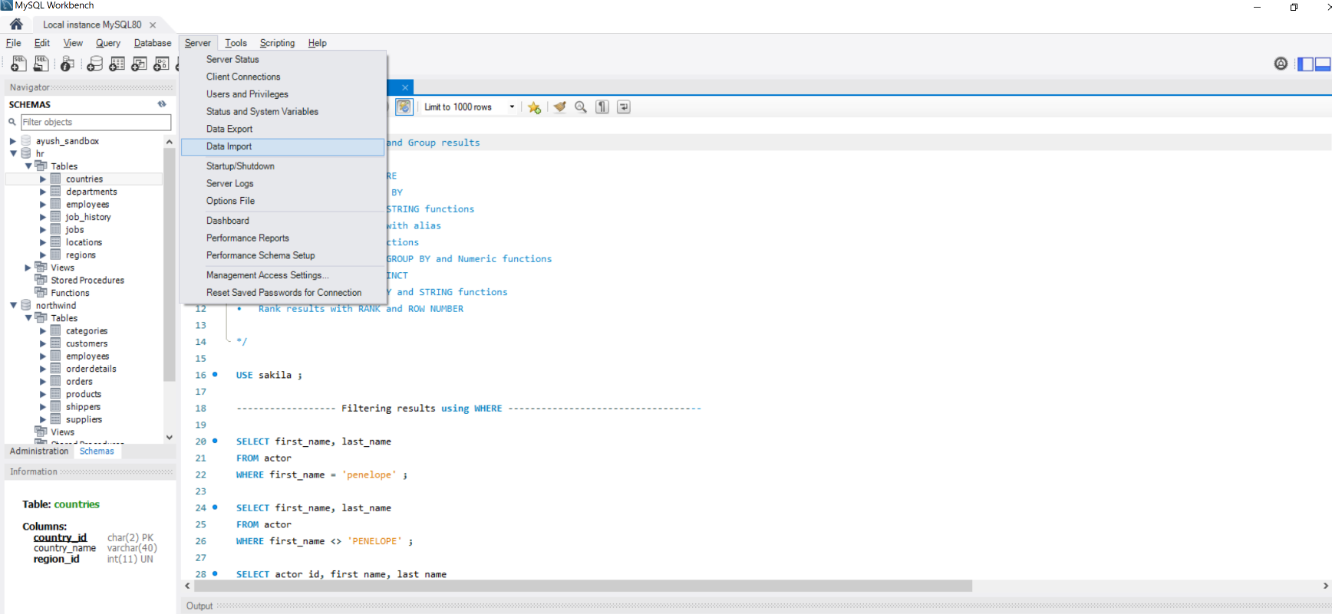

1. Select Import from Self-Contained file and select the path of the folder where the unzipped databases are placed

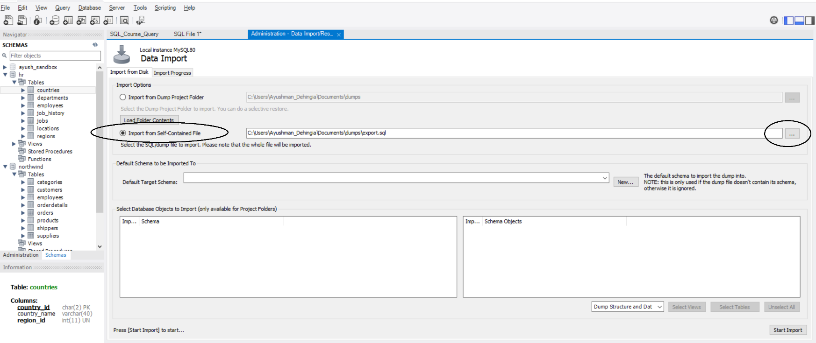

1. Select the Database and click Open

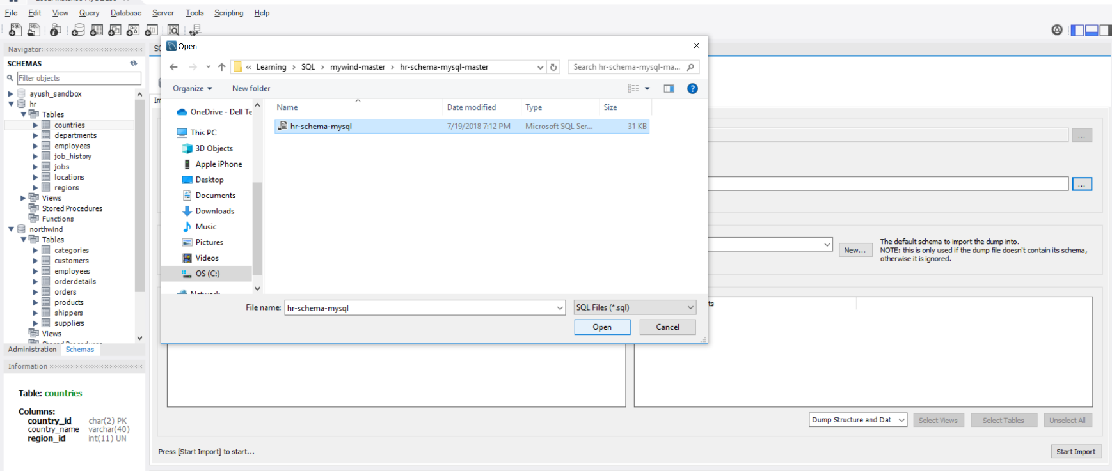

1. Click on Start Import and once it’s successfully done, click on the button for Refreshing the Schemas. The new database will then appear on the list

